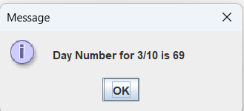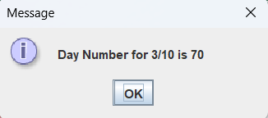

Day：
package as05;

public class Day
{
private int day;
protected int month;

public Day(int d, int m)
{
day = d;
month = m;
}

public int findDayNum()
{
int dayNum = 0;
switch (month)
{
case 1:
dayNum = day;
break;
case 2:
dayNum = 31 + day;
break;
case 3:
dayNum = 31 + 28 + day;
break;
case 4:
dayNum = 31 + 28 + 31 + day;
break;
case 5:
dayNum = 31 + 28 + 31 + 30 + day;
break;
case 6:
dayNum = 31 + 28 + 31 + 30 + 31 + day;
break;
case 7:
dayNum = 31 + 28 + 31 + 30 + 31 + 30 + day;
break;
case 8:
dayNum = 31 + 28 + 31 + 30 + 31 + 30 + 31 + day;
break;
case 9:
dayNum = 31 + 28 + 31 + 30 + 31 + 30 + 31 + 31 + day;
break;
case 10:
dayNum = 31 + 28 + 31 + 30 + 31 + 30 + 31 + 31 + 30 + day;
break;
case 11:
dayNum = 31 + 28 + 31 + 30 + 31 + 30 + 31 + 31 + 30 + 31 + day;
break;
case 12:
dayNum = 31 + 28 + 31 + 30 + 31 + 30 + 31 + 31 + 30 + 31 + 30 + day;
break;
}
return dayNum;
}

public int getDay()
{
return day;
}

public int getMonth()
{
return month;
}
}

TestDay：
package as05;
import javax.swing.JOptionPane;

public class TestDay
{
public static void main(String[] args)
{
int day, month, year, dayNum;
String input;

// Prompt the user for entering day, month, year values
input = JOptionPane.showInputDialog("Enter day");
day = Integer.parseInt(input);

input = JOptionPane.showInputDialog("Enter month");
month = Integer.parseInt(input);

input = JOptionPane.showInputDialog("Enter year");
year = Integer.parseInt(input);

// Create an object of class Day and pass its constructor
// day and month values provided by the user
Day dayObj = new Day(day, month);

// Call findDayNum of Day object to obtain day number
dayNum = dayObj.findDayNum();

// Add 1 to dayNum if it's a leap year and month greater than 2
// Handle the leap year
if (((year % 400) == 0) || (((year % 4) == 0) && ((year % 100) != 0)))
{
// Leap year
if (month > 2)
{
dayNum = dayNum + 1;
}
}

// Display the original data and the day number
String output = "Day Number for " + month + "/" + day + " is " + dayNum;
JOptionPane.showMessageDialog(null, output);
}
}

